1.7.3-CD SkillTag Class Diagram

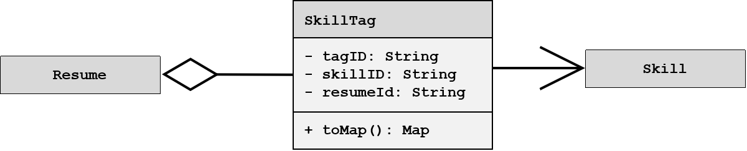

1.7.3-CD ResumeSubmission Class Diagram

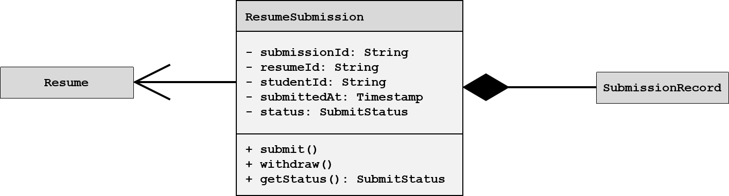

1.7.5-CD ValidationResult Class Diagram

